**Learning Outcomes**

1. Understanding Spinner, Image View, Dialogs
2. Understanding Seek bar

**Design a layout as shown below**

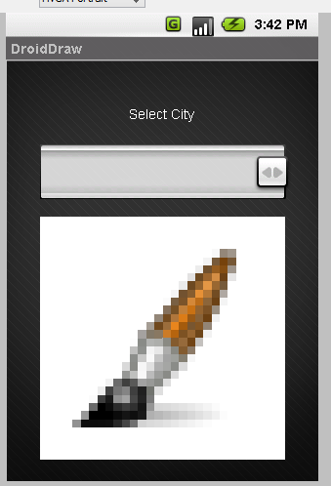

Add a spinner and an Imageview

Under values



Add pictures of cities in the drawable folder (** Do not have – (dash) or _ (underscore) in the filenames for pictures)

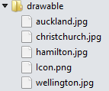

Declare an array as shown in String.xml

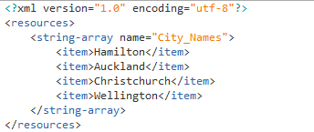

Write Down the following code

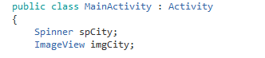

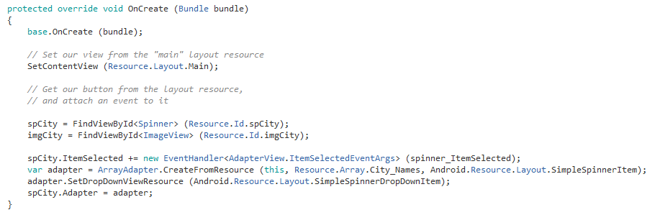

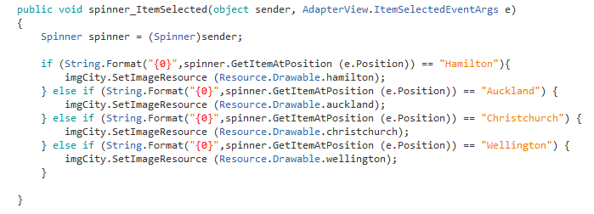

**Alert Dialogs**

Single Button, Two button or Three Button alert dialogs

This is a type of dialog, where content is displayed with a dialog title and a button. The following layout is for the example of displaying alert dialogs. We have three buttons.

 

Write the following code









**Seekbar**

SeekBar is another input type control. It takes user’s input to change the SeekBar value. Normally in windows we use Slider control for this.

**Design a layout as shown below**

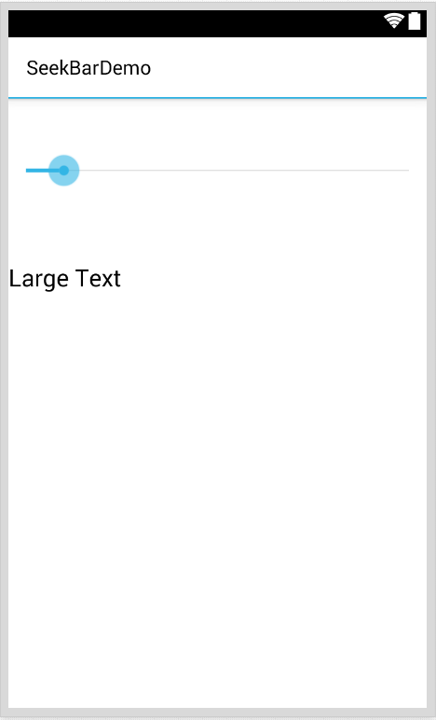

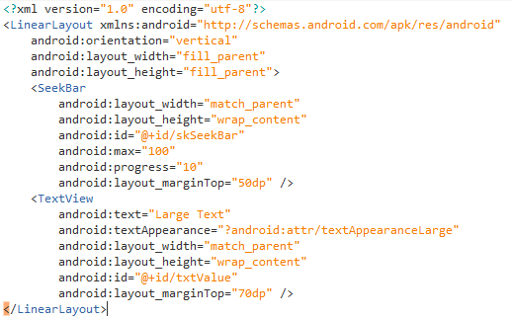

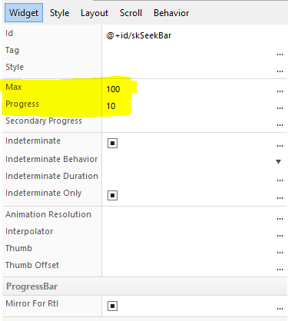

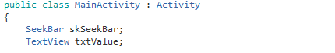

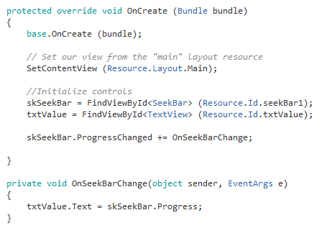

**Exercise**

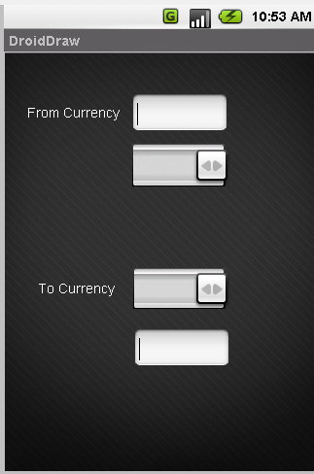

**Design a Currency Converter App**

Add the currency in strings.xml

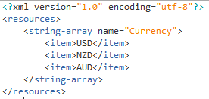

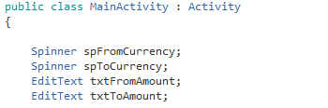

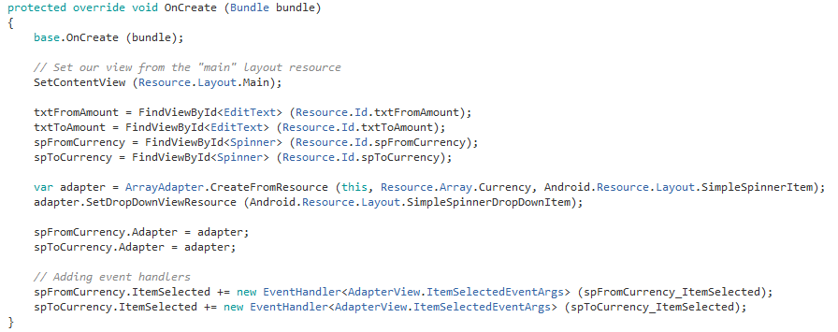

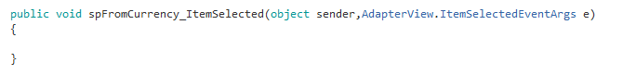

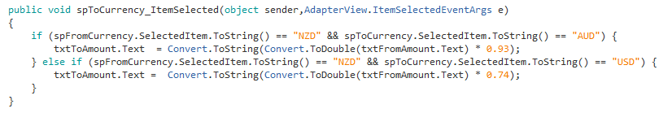

**A Length and Distance Converter App**

